Mollie Makes Commission: Kaliko natural dye drawstring backpack

Issue: 98 (on sale 9 October 2018)

Deadline: 13 August

Swatches and/or Sketches: throughout process

Fee: £120

P.O. to follow

Please send a photograph of the finished piece for approval before posting.

Please send over swatches and sketches as you’re working on the project so we can get an idea of how it’s progressing. That way, we can make sure we’re both on the same page before you start making it up. After you have read through the brief, let me know if you have any questions at all.

Overview:
A tutorial for a naturally dyed drawstring bag. Made for an adult, the bag will feature two colour blocks of naturally dyef fabric, a lining, draw string straps and plant stencil detailing. A perfect dying and sewing project for autumn.

Please supply the finished 500-word tutorial in 12 steps, with 12 step photographs showing key parts of the make (see below for full requirements), a styled photograph of the finished item, and send the finished project in by midday on the deadline day for photography.

Sizing
To fit: adult

Inspiration and colours
We love your below designs, and would love to see a peach/pink and grey, or yellow and pink for the colour block.

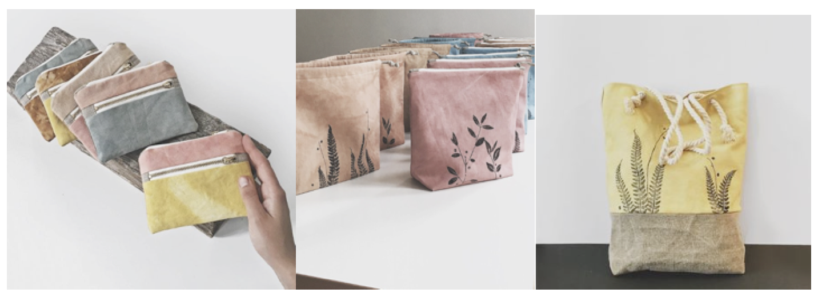

Please approve colours, design and materials with us before making up the full project. Try and use materials that are widely available or easy to substitute.

Please provide us with the following and send the finished item to the address below:

Lindsey Newns,
Mollie Makes,
Immediate Media
2nd Floor, Tower House
Fairfax Street
Bristol
BS1 3BN

WORDS:
1. Materials list. Please list all branded materials or tools used, or let us know where you sourced them. Please check that materials are not about to be discontinued, and that the project can be easily made with an alternative if need be (mostly applicable to knit/crochet projects).

2. Abbreviations (if relevant)

3. A 500-word step-by-step walkthrough for the project that relates to each picture. Please mark-up which step belongs with each picture by numbering them in the same way (Step 1, Step 2, Step 3 etc).

4. 3 special tips relating to the project that we can use in the intro, or elsewhere on the page.

5. 50 words about yourself that are written in the third person: your life, hobbies, crafts, loves and a URL to your blog/Etsy shop etc.

6. 50 words about yourself that are a bit more quirky, light-hearted and fun, written in the third person, which we can use on our contributors’ page. For example: "Lara always wanted to be a ballerina, and can often be found twirling around her studio when she’s not busy designing."

NOTE: Please send everything listed above within ONE Word document. Please do not send as a PDF.

IMAGES:
1. High res photographs for each step listed in your instructions, named in the same way (Step 1, Step 2, Step 3 etc.). High res is 300dpi at A4 size for this feature. If you send images not taken by you, please give us the photographer contact details so we can clear usage rights. Please keep to 12 steps. If you require more or fewer steps, let us know. Please take all shots on the same plain/light background for consistency.

2. A high res image of the finished project in a styled/propped setting (for our Next month page and for our reference).

3. Templates or charts, if needed. Please provide as a JPG (or PDF) at full size.

4. A high res image of yourself.

5. Details of your blog/website/Etsy shop.

NOTE: Please send all of the above together, labelled and filed into folders as neatly as possible. If your images are too large to send over email, please use a Dropbox share link, WeTransfer or a similar file-sharing site to get your work to us.
DO NOT provide multiple shots for each step in your instructions (unless it requires two stages such as: Step 1a, Step 1b) – instead, choose the best shots to illustrate each step. ***

Even if you have sent in some of the items above for features in a previous issue (head shots, personal bio etc.), we DO need you to send them all in to us again – alongside your new project assets.

Please send your work to Lindsey Newns (lindsey.newns@immediate.co.uk) before midday on deadline day.

Please send your invoice to accounts.payable@immediate.co.uk referencing the P.O. number. It is important you also include your Contributor Invoice Number. If you don't have a system for that, just use 001 or something similar. If you're claiming VAT, please make that clear. Please make sure you fill in your bank details as we pay by bank transfer.

If you have any questions regarding the brief, let us know. For contract queries, please contact Kristin Eriksen (kristin.eriksen@immediate.co.uk). For invoice queries, please contact accounts (address above).

PLEASE DO NOT share photos or information about your commission on your social media channels/blog until the issue goes on sale. We like to keep our content exclusive and surprising to our readers.

Many thanks!

Lindsey

